Cash to be used in fewer than half transactions by 2015

Cash will be used in fewer than half of all transactions by 2015, according to an official report which suggests plastic is rapidly overtaking notes and coins in consumers' pockets.
By Harry Wallop, Consumer Affairs Editor Published: 7:00AM BST 14 Apr 2010
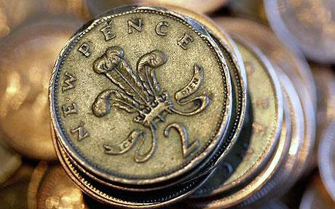
Cash to be used in fewer than half transactions by 2015
Last year 59 per cent of the 37 billion transactions were done with cash, a sharp decline from the 73 per cent of transactions that were made with cash just 10 years ago.
According to the Payments Council, a trade body representing the banks, card and cash machine industry, this proportion will fall to below 50 per cent by 2015, and to 45 per cent by 2018.
The figures have alarmed some campaigners, who gave warning that banks should not encourage the march towards a cashless society.
The Way We Pay 2010 report from the Payments Council analysed in detail the revolution that has happened since 1966, the year that the first credit card was issued, followed one year later by the first cash dispenser being trialled.
It pointed out that in that time the majority of people had gone from being paid in cash at the end of the week, to being paid once a month by a direct transfer into their bank account. Just one in twenty workers were paid wages in cash last year, it calculated, a figure predicted to fall to a mere one in 50 by 2018.
Because of this trend and the rise of debit cards and direct debit payments, cash has markedly fallen from favour, the report said.
"The trend is well entrenched and will continue. Paying for things is more secure and more convenient now we don’t have to keep replenishing the stock of paper and metal we drag around. By 2018, the amount of cash we use will fall by 20 per cent after adjusting for inflation, even though our total spending will rise by perhaps 15 per cent in real terms," the report said.
"And this is probably a conservative estimate," added a spokesman, who pointed out that of the 21 billion cash transactions last year, 19 billion were for less than £15. This is the limit that people can spend on so-called contactless payment cards, a type of debit card which can be used in some corner and sandwich shops, whereby the consumer does not need to type in any PIN security code.
Mark Hunter, the Liberal Democrat MP, who has led the campaign to save the chequebook, said: "This is not something the public are asking for. It is the arrogance of the banks which is pushing for these changes.
"There is a whole generation of people, especially over the age of 60, for whom cash is part of their daily lives."
Ron Delnevo, the managing director of Bank Machine, a cash dispensing company, said: "Yes, cards can be more convenient. But sensible people use cash. If you have £10 in your pocket you know you can only spend £10. With plastic you can easily lose track of what you are spending and get into debt.
"I am concerned that there is a huge head of steam building behind the card issuers to push out cash. But that is not in the interest of the general public."
Jonathan Welfare, chief executive of the anti-poverty charity Elizabeth Finn Care, said cash was still a key part of life for the 1.7 million who did not have a bank account. “If you don’t have a card it is increasingly difficult to make everyday payments. If you want to pay a utility bill or a fine you have to trek to the nearest Post Office, which thanks to the recent closures are now few and far between, meaning long journeys to do what would be a simple task if armed with a debit card.
"These people are being left behind in a society where cash is no longer king,” he said.

Tasks
- What trend is the article describing?

- What are the arguments against cash?

- What are the arguments for cash as a medium of exchange?

